Database Design Document

# Introduction

From the ThinkCube invoice file, we have reverse engineered a logical and physical ERD as well as a DDL SQL file to establish a relational database that can accurately capture the details and process of the invoice file. This document will serve as a companion to the SQL file as it lists our assumptions and constraints regarding the invoice and continues with our team and some problematic issues and some areas that could be improved upon. The bulk of this document will consist of listing and describing the entities and their attributes as well as noting our design decision regarding them. Finally it will conclude with the logical and physical ERD for a graphical representation of our work.

# Assumption and Constraints

We have decided to assume that the company operates throughout Canada and the PDF shown is from the Ottawa branch hence the 13% Ontario tax rate. We were also uncertain about the nature of the client to whom the product was shipped; whether this client is strictly on the receiving end of the orders or has also placed an order from our company.

# Identified Issues

Since our company operates across Canada, one potential issue is the lack of a tax rate attribute in the branch table however this could be remedied by using the city and postal code to determine the province and from there, determine the provincial tax rate. In the future, we would recommend expanding details to the shipping table such as email, a counter of how many times we have engaged their services previously, and our experience with them. Establishing a m:m relation between product_t and shipper_t would also be beneficial to our database in the future so that we can determine which shipping company is the optimal choice for a specific product.

# Personnel

* Database Architect: Stanley Yoo
* Systems Analyst: Sifat Jamaly
* Software Engineer: Nathan Fan

# Entities

Database Name: InvoiceDB Revision: 2.54

Date: 2020-04-07

Author: Stanley Yoo

|  |  |  |
| --- | --- | --- |
| Entity Name | Entity Type | Relates to |
| branch_t | table | employee_t |
| employee_t | table | branch_t, customer_t |
| customer_t | table | employee_t, invoice_t, payment_t |
| invoice_t | table | customer_t, payment_t, shipper_t, invoice_product_t |
| payment_t | table | cusomter_t, invoice_t |
| shipper_t | table | invoice_t |
| invoice_product_t | table | product_t, invoice_t |
| product_t | table | invoice_product_t |

Notes: invoice_product_t acts as an associative entity which links product_t and invoice_t and invoice_t serves the same role between shipper_t and customer_t.

# Entity Details

## Fields form – <branch_t>

Database Name: InvoiceDB Revision: 1.36

Entity Name: branch_t Date: 2020-04-02

Author: Nathan Fan

|  |  |  |  |
| --- | --- | --- | --- |
| Field Name | Data type | Field Properties | Relates to |
| branch_id | char(3) | Primary key | emp_branch |
| branch_phone | varchar(15) | not null |  |
| branch_fax | varchar(15) | not null |  |
| branch_address | varchar(20) | not null |  |
| branch_city | varchar(15) | not null |  |
| branch_prov | char(2) | null |  |
| branch_postcode | char(6) | not null |  |

Notes:

branch_prov is permitted to be null as it can be derived from branch_postcode. All other fields cannot be null since the company headquarters in Toronto must be able to contact its branches throughout the nation.

## Fields form – <employee_t>

Database Name: InvoiceDB Revision: 3.42a

Entity Name: employee_t Date: 2020-04-05

Author: Sifat Jamaly

|  |  |  |  |
| --- | --- | --- | --- |
| Field Name | Data type | Field Properties | Relates to |
| emp_id | char(4) | Primary key | cust_salesperson_id |
| emp_branch | char(3) | Foreign key | branch_id |
| emp_fname | varchar(30) | not null |  |
| emp_lname | varchar(30) | not null |  |
| emp_email | varchar(20) | not null |  |
| emp_phone | varchar(15) | not null |  |
| emp_title | varchar(15) | null |  |

Notes:

An employee’s first and last names as well as their contact information cannot be null because the company and its clients must be able to identify and message the employee responsible for any order. The title can be blank because only one specific class of employees deals with shipping contracts so the title can be assumed or it can be derived from a combination of emp_id and emp_email.

## Fields form – <payment_t>

Database Name: InvoiceDB Revision: 2.98

Entity Name: payment_t Date: 2020-04-03

Author: Nathan Fan

|  |  |  |  |
| --- | --- | --- | --- |
| Field Name | Data type | Field Properties | Relates to |
| pay_id | char(5) | Primary key |  |
| pay_invoice_id | char(5) | Foreign key | inv_id |
| pay_paid_by | char(5) | Foreign key | cust_id |
| pay_amount | numeric(5,2) | not null |  |
| pay_due_date | date | null |  |
| pay_cc_number | char(16) | not null |  |
| pay_cc_expire_date | date | not null |  |
| pac_cc_cvv | char(3) | not null |  |

Notes: pay_due_date can be derived from the order date of the invoice.

## Fields form – <customer_t>

Database Name: InvoiceDB Revision: 1.74

Entity Name: customer_t Date: 2020-04-04

Author: Stanley Yoo

|  |  |  |  |
| --- | --- | --- | --- |
| Field Name | Data type | Field Properties | Relates to |
| cust_id | char(5) | Primary key | pay_paid_by, inv_ship_to |
| cust_fname | varchar(30) | not null |  |
| cust_lname | varchar(30) | not null |  |
| cust_company | varchar(30) | null |  |
| cust_phone | varchar(15) | not null |  |
| cust_address | varchar(20) | not null |  |
| cust_city | varchar(15) | not null |  |
| cust_prov | char(2) | null |  |
| cust_postcode | char(6) | not null |  |
| cust_salesperson_id | char(4) | Foreign key | emp_id |

Notes: cust_prov can be derived from cust_address and cust_postcode. If the customer’s name consists of more than two parts, only the first and last elements will be stored in cust_fname and cust_lname respectively to preserve atomicity.

## Fields form – <Invoice_t>

Database Name: InvoiceDB Revision: 4.85

Entity Name: invoice_t Date: 2020-04-01

Author: Stanley Yoo

|  |  |  |  |
| --- | --- | --- | --- |
| Field Name | Data type | Field Properties | Relates to |
| inv_id | char(5) | Primary key | pay_invoice_id |
| inv_ship_to | char(5) | Foreign key | cust_id |
| inv_order_date | date | null |  |
| inv_description | varchar(60) | null |  |
| inv_shipper_id | char(5) | Foreign key | ship_id |
| inv_delivery_date | date | null |  |

Notes: invoice_t is the linchpin that connects the rest of the tables together by serving as an associative entity between customer_t and shipper_t which is a m:m relationship. It also serves as a bridge between the client and the product as well as the shipping details.

## Fields form – <shipper_t>

Database Name: InvoiceDB Revision: 5.32

Entity Name: shipper_t Date: 2020-04-02

Author: Nathan Fan

|  |  |  |  |
| --- | --- | --- | --- |
| Field Name | Data type | Field Properties | Relates to |
| ship_id | char(5) | Primary key | inv_shipper_id |
| ship_company_name | varchar(30) | not null |  |
| ship_phone | varchar(15) | not null |  |

Notes: Contact information cannot be null since we must be able to reach the company responsible for delivering our products to our clients.

## Fields form – <invoice_product_t>

Database Name: InvoiceDB Revision: 2.31

Entity Name: invoice_product_t Date: 2020-04-07

Author: Sifat Jamaly

|  |  |  |  |
| --- | --- | --- | --- |
| Field Name | Data type | Field Properties | Relates to |
| inv_id | char(5) | Primary/Foreign key | invoice_t.inv_id |
| prod_id | char(5) | Primary/Foreign key | product_t.prod_id |
| line_unit | integer | not null |  |
| line_price | numeric(5,2) | not null |  |

Notes: This table is the associative entity establishing the m:m relationship between product_t and invoice_t. line_unit and line_price cannot be blank since the price and quantity of the product ordered from our company is a crucial detail in the invoice.

## Fields form – <product_t>

Database Name: InvoiceDB Revision: 1.74

Entity Name: product_t Date: 2020-04-04

Author: Sifat Jamaly

|  |  |  |  |
| --- | --- | --- | --- |
| Field Name | Data type | Field Properties | Relates to |
| prod_id | char(5) | Primary key | invoice_product_t.prod_id |
| prod_description | varchar(60) | not null |  |
| prod_price | numeric(5,2) | not null |  |
| prod_discount | numeric(5,2) | null |  |
| prod_qoh | integer | not null |  |

Notes: prod_discount can be null as there might not be a discount on the specific product.

# Basic ERD

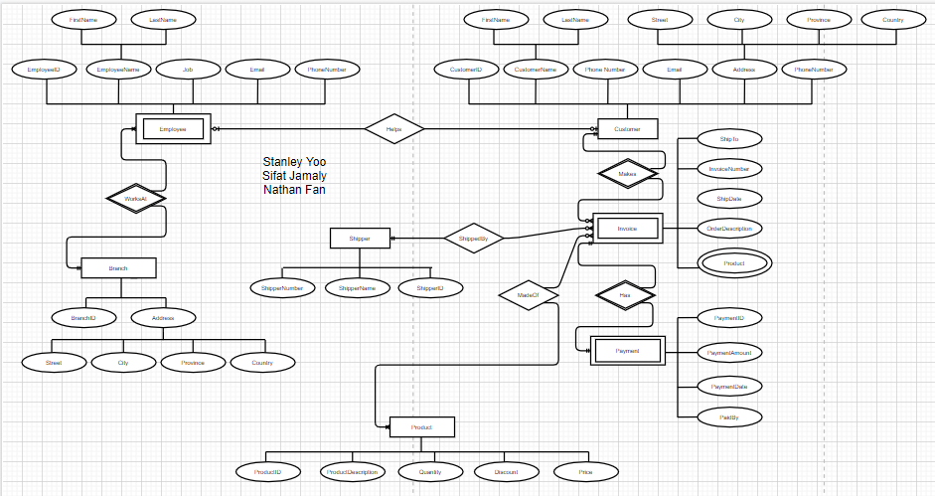

# Physical ERD

